23rd October 2024

Dear Parent / Carer of

Throughout each term, teachers continually assess children to ensure that any gaps in their learning are identified.

With this in mind, after half term Miss Oakes will be running a small, focused learning Maths group for a selected number of children each Wednesday morning before school.

This group is offered free of charge and attendance is strongly advised.

The group will start 7.45am. Children should be accompanied to the main school gates where Miss Oakes will meet them.

The aim of this group is to support children’s learning in particular areas of the maths curriculum.

Yours sincerely

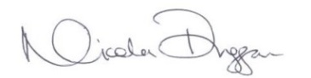
Mrs N Duggan
Headteacher

